Default Methods in Interface:
From 1.8 onwards, we can define a concrete method in the form of default method.
The implementation class uses the default method or it can override.
Example: Use default method
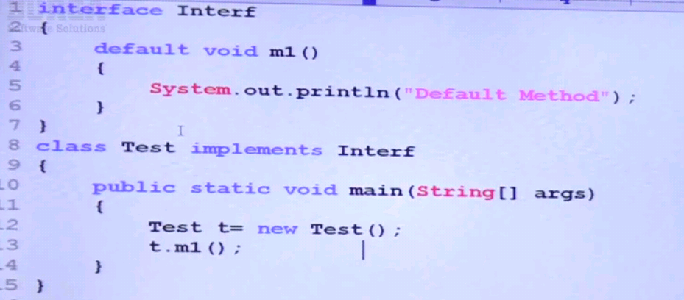

Override default method:
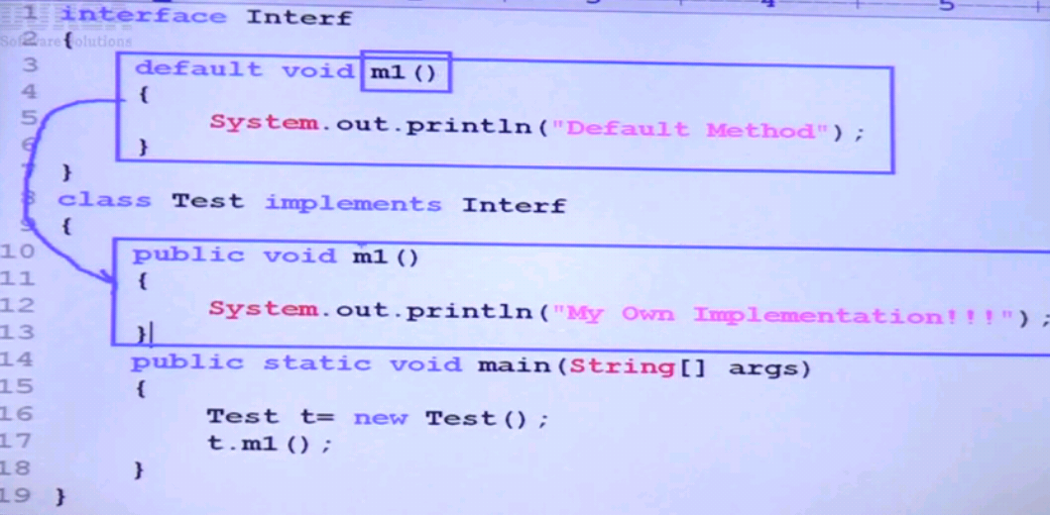

Default method wrt Inheritance:
Default method issue with multiple inheritance:
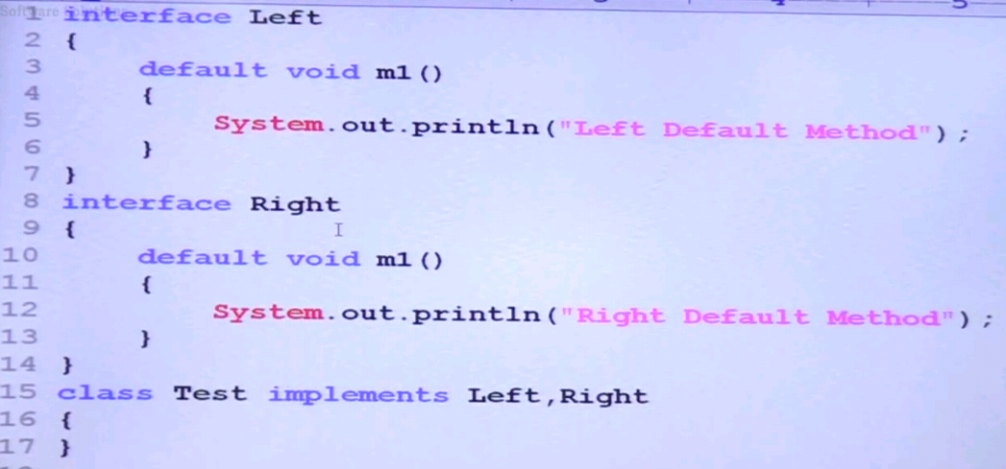
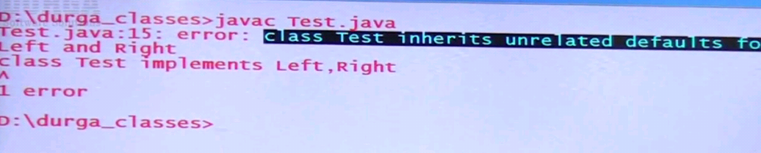
Note : If two interfaces have same default methods with same signature, when implementing both interfaces, we will get above ambiguity exception.
- In such cases, override the default method in the implementing class.
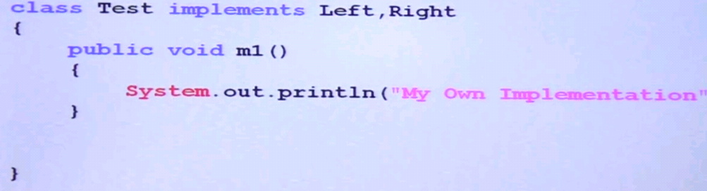

- If we need default method from specific interface, then call Left.super() or Right.super() in the overriding default method of implementation class.
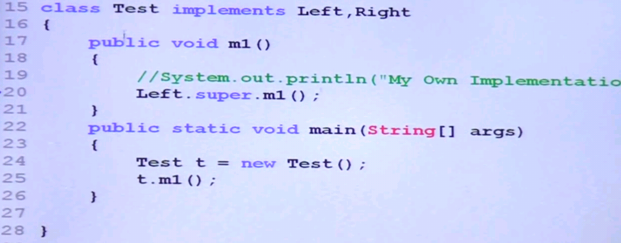

Differences b/w interfaces with default methods and abstract methods:
If we add a concrete method in the form default method, then what is the difference between interface and abstract class.
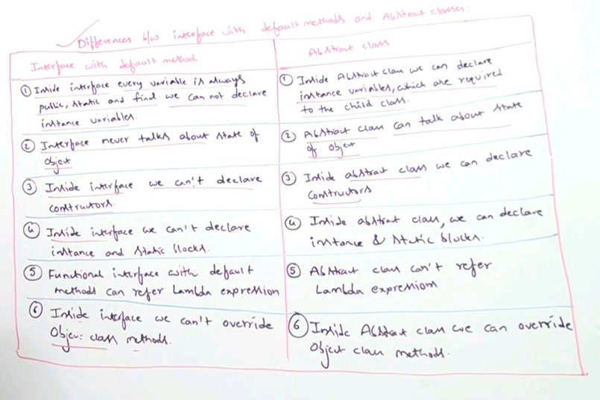

Static methods inside interface:
From 1.8 onwards, we can declare static methods in interface.
Purpose: to define general utility function for other classes.
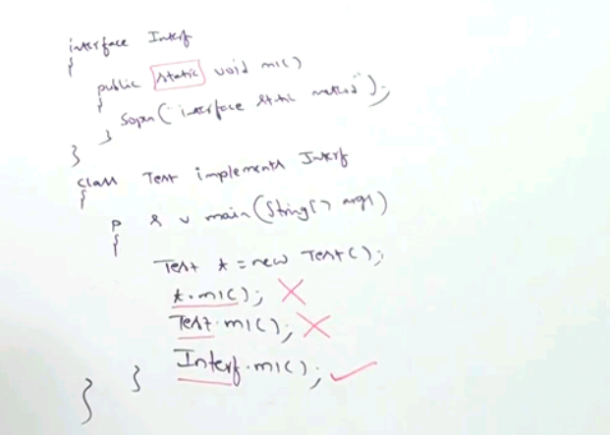
Note : The static method in Interface is not available to implemented class. So we can call the static method of an interface by using Interface name only.
Static methods wrt Inheritance:
Inheritance is not applicable for static methods. We can define same static method with same signature in multiple interface and its implementation classes also. There is no override concept for static methods.
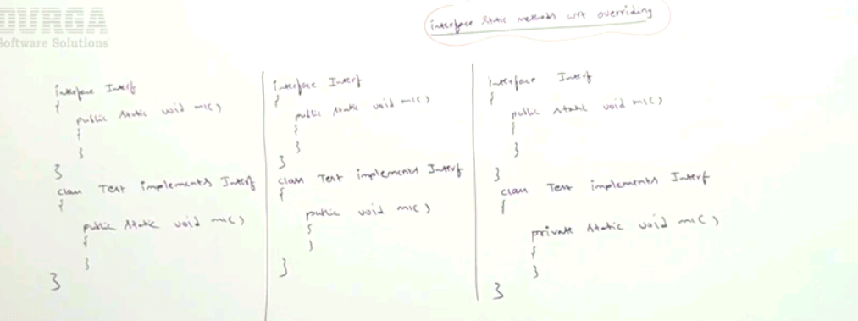

From 1.8 onwards, we can define static main() in interface, we can run the main() in interface from command prompt directly.
